Product category: AC DRIVES (VFD’s)

AC DRIVE COMPANY

SIEMENS

1. Model name: SIEMENS V20 AC DRIVE

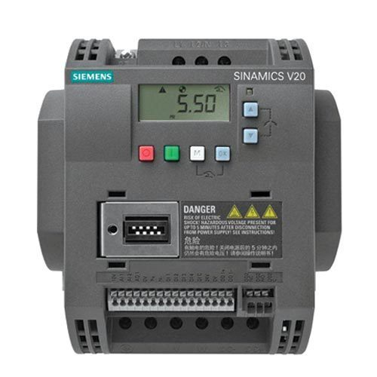

1. **MODEL NAME : SIEMENS SINAMICS G120 DRIVE**

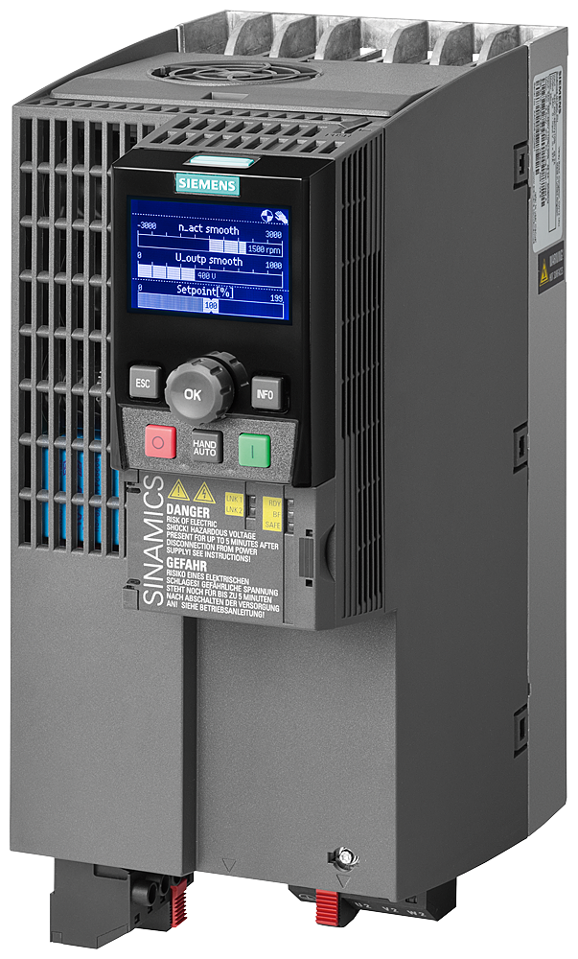

1. MODEL NAME: SIEMENS SINAMICS G130 SERIES

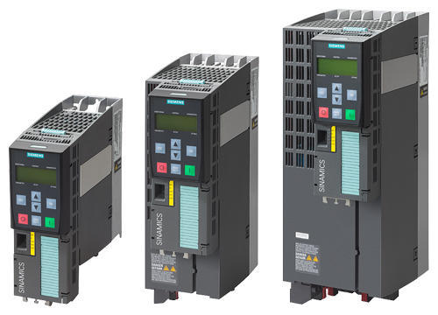

1. MODEL NAME: SIEMENS G110 SERIES

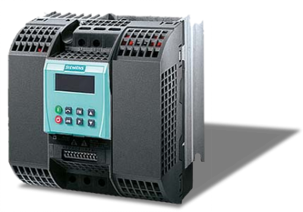

1. MODEL NAME: ALL OTHER SIEMENS AC DRIVES

[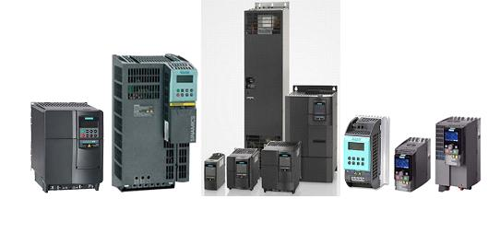](https://www.deltaelectronicsindia.com/industrial-automation/touch-panel-hmi-human-machine-interfaces/tp70p/" \o "TP70P)